Book

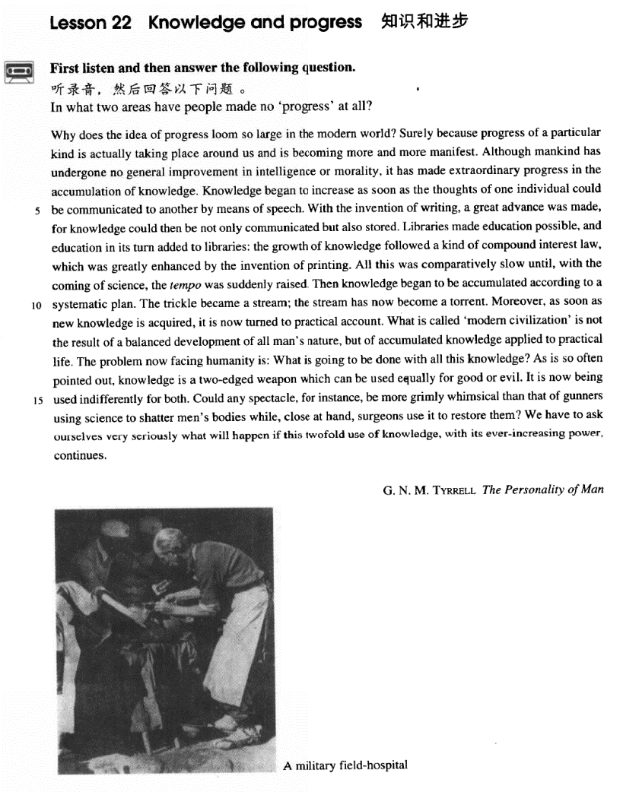

课文

Why does the idea of progress loom so large in the modern world?

为什么进步这个概念在现代世界显得如此突出？

Surely because progress of a particular kind is actually taking place around us and is becoming more and more manifest. Although mankind has undergone no general improvement in intelligence or morality,

无疑是因为有一种特殊的进步实际上正在我们周围发生，而且变得越来越明显。虽然人类有智力和道德上没有得到普遍提高，

it has made extraordinary progress in the accumulation of knowledge.

但在知识积累方面却取得了巨大的进步。

Knowledge began to increase as soon as the thoughts of one individual could be communicated to another by means of speech.

人一旦能用语言同别人交流思想，知识的积累便开始了。

With the invention of writing, a great advance was made, for knowledge could then be not only communicated but also stored.

随着书写的发明，又迈进了一大步，因为这样一来，知识不仅能交流，而且能储存了。

Libraries made education possible, and education in its turn added to libraries:

藏书使教育成为可能，而教育反过来又丰富了藏书，

the growth of knowledge followed a kind of compound interest law,

因为知识的增长遵循着一种“滚雪球”的规律。

which was greatly enhanced by the invention of printing.

印刷术的发明又大大提高了知识增长的速度。

All this was comparatively slow until, with the coming of science, the tempo was suddenly raised.

所有这些发展都比较缓慢，而随着科学的到来，增长的速度才突然加快。

Then knowledge began to be accumulated according to a systematic plan.

于是，知识便开始有系统有计划地积累起来。

The trickle became a stream: the stream has now become a torrent.

涓涓细流汇成小溪，小溪现已变成了奔腾的江河。

Moreover, as soon as new knowledge is acquired, it is now turned to practical account.

而且，新知识一旦获得，便得到实际应用。

What is called 'modern civilization' is not the result of a balanced development of all man's nature,

所谓“现代文明”并不是人的天性平衡发展的结果，

but of accumulated knowledge applied to practical life.

而是积累起来的知识应用到实际生活中的结果。

The problem now facing humanity is: What is going to be done with all this knowledge?

现在人类面临的问题是：用这些知识去做什么？

As is so often pointed out, knowledge is a two-edged weapon which can be used equally for good or evil.

正像人们常常指出的，知识是一把双刃刀，可以用于造福，也可以用来为害。

It is now being used indifferently for both.

人们现在正漫不经心地把知识用于这两个方面，

Could any spectacle, for instance, be more grimly whimsical than that of gunners using science to shatter men's bodies while, close at hand, surgeons use it to restore them?

例如：炮兵利用科学毁坏人的身体、而外科医生就在附近用科学抢救被炮兵毁坏的人体，还有什么情景比这更可怕、更怪诞的吗？

We have to ask ourselves very seriously what will happen if this twofold use of knowledge, with its ever-increasing power, continues.

我们不得不严肃地问问我们自己：随着日益增长的知识的力量，如果我们继续利用知识的这种双重性，将会发生什么样的情况呢？

词汇讲解

Lesson 22 Knowledge and progress

manifest ['mænɪfest]

adj. 明显的

manifest adj. clear; obvious explicit

explicit instructions

Possible side effects should be made explicit.

a sexually explicit movie implicit

an implicit criticism of government policy manifest vt. 使……显露出来

Musical talent usually manifests itself in childhood.

The fact of first-rate importance is the predominant role that custom plays

in experience and in belief, and the very great varieties it may manifest. morality [mə'ræləti]

n. 道德

morality public morality enhance people’s consciousness of public morality moral adj. 道德的；道义的

morals n. 道德标准

the morals and customs of the Victorian period ethics n. 职业道德

medical / commercial / journalistic ethics

values n. 价值观

traditional / conservative / liberal values compound ['kɒmpaʊnd]

adj. 复合的

a compound noun / adjective / sentence

compound interest simple interest

compound n. 化合物；复合词

be compounded of / from…

The DNA molecule is compounded of / from many smaller molecules. indifferently [ɪn'dɪfrəntlɪ]

adv. 冷漠地，不在乎地

be indifferent to …

How can you be indifferent to the sufferings of the refugees? be apathetic about …

be unsympathetic to …

It makes no difference to me. I don’t mind / care.

It’s all the same to me.

It makes a lot of / a whole world’s difference to me. It matters to me.

It means a lot to me.

It weighs heavily with me.

whimsical ['wɪmzɪkl]

adj. 稀奇古怪的，异想天开的

whimsical whimsy

one of her bizarre whimsies

whim on a whim

We bought the house on a whim. at the whim of sb.

I always been afraid to go up in an airplane. Now I'm gonna jump out of one at the whim of a maniac!

shatter ['ʃætə(r)]

v. 粉碎

shatter v. to break something suddenly into pieces 突然把某物打成粉碎

One of his knees was shattered by a bullet. shatter one’s hopes / illusions / confidence

shatter the peace / silence

smash

smash-and-grab

smash a window / glass

smash terrorism

smash the Gang of Four crush

crush the rebellion / uprising

loom large

Human right issues will continue to loom large in China-U.S. relations. The adverse effects of the Great Leap Forward and of the Cultural Revolution still loom large in the minds of Chinese policy makers. question-answer pattern

question (why …) answer (because …) supportive sentences

Why, you may wonder, should spiders be our friends? Because they destroy so many insects, and insects include some of the greatest enemies of the human race. …

Surely because progress *of a particular kind* is actually taking place around us and is becoming more and more manifest.

kind / sort / type

a kind of + 不可数名词/可数名词单数

a particular kind of progress a new kind of machine

The more expensive kind of antique shop where rare objects are beautifully displayed in glass cases to keep them free from dust is usually a forbidding place.

不可数名词/可数名词复数 + of a kind

progress of a particular kind machines of a new kind

a kind of … / a sort of … a sort of paradise

a sort of hero

An atom is a kind of solar system.

be becoming more and more / increasingly + adj.

So great is our passion for doing things for ourselves, that we are becoming increasingly less dependent on specialized labour.

As a result of all these factors, governments are becoming increasingly dependent on biologists and social scientists for planning the appropriate programs and putting them into effect.

Although mankind has undergone no general improvement in intelligence or morality, it has made extraordinary progress in the accumulation of knowledge.

undergo (underwent,undergone)

experience go through

know see witness undergo surgery

Mankind has undergone no general improvement. The bridge has undergone a series of modifications.

experience difficulties go through a crisis

He has seen / known so much misery.

The 1980s witnessed enormous growth in the economy. make (an) improvement / improvements in …

make progress in ...

make an advance / advances in…

great, enormous, considerable, extraordinary, substantial … man he

mankind / the human race it Man has his problems.

Mankind / The human race has its problems.

It comes nearer to the engines with which man has 'conquered' the air, as he boasts.

increase v. grow / accumulate

communicate sth. to sb.

communicate with sb. convey sth.

His tone conveyed an unmistakable warning. commune with sb.

commune with God

Lying in the woods, he felt he was communing with nature. Oral language precedes written language.

Without written language, the only way to preserve knowledge is to hand it down from one generation to another, and in the process some information would inevitably be missing or distorted.

With the invention of writing, a great advance was made, *for knowledge could then be not only communicated but also stored*.

with the approach of Christmas with the advance of science with the outbreak of war

with the coming / arrival / advent of Easter With the evidence began to accumulate, … X As the evidence began to accumulate, … √

The invention of writing enabled mankind to make a great advance in the preservation of knowledge.

The invention of writing brought about a great advance in the

preservation of knowledge. undergo general improvement make extraordinary progress make a great advance

Libraries made education possible, and education in its turn added to libraries: the growth of knowledge followed a kind of compound interest law, which was greatly enhanced by the invention of printing.

in (its) turn 反过来；转而又……

Poverty led to social unrest, which in (its) turn aggravated poverty. Theory is based on practice and in (its) turn serves practice.

vice versa

Boys can date girls, and vice versa. add to sth. = increase sth.

The music added to our enjoyment.

Her colleague’s laughter added to her embarrassment. The balloons added to the festive atmosphere.

莫听穿林打叶声

何妨吟啸且徐行竹杖芒鞋轻胜马谁怕

一蓑烟雨任平生

料峭春风吹酒醒微冷

山头斜照却相迎回首向来萧瑟处归去

也无风雨也无晴

定风波 苏轼

All this was comparatively slow until, with the coming of science, the tempo was suddenly raised.

with the coming / arrival / birth / advent / dawn / genesis of science the tempo of the growth of knowledge

turn sth. to … account

turn knowledge to practical account

He turned his negotiating skills to very good account in the meeting. What is called 'modern civilization' is not the result of a balanced

development of all man's nature, but of accumulated knowledge *applied*

*to practical life*.

The problem *now facing humanity* is: What is going to be done with all this knowledge?

As is so often pointed out, knowledge is a two-edged weapon *which can*

*be used equally for good or evil*.

It is so often pointed out that knowledge is … √

As it is so often pointed out that knowledge is … X As (is) so often pointed out, knowledge is … √

It is reported that Chinese President Xi Jinping will pay an official visit to the United States.

As (is) reported, Chinese President Xi Jinping will pay an official visit to the United States.

two-edged / double-edged weapon / sword

Fame can be a double-edged sword. a battle between good and evil

Knowledge benefits mankind and at the same time poses a threat

constitutes a menace

As Sir Francis Bacon once pointed out, knowledge is power. Power can be used for good or evil; and since the genie that brings new knowledge is already out of the bottle, we must learn to direct the use of the resultant power rather than curse the genie or try to confine him.

Could any spectacle, *for instance*, be more grimly whimsical than that of gunners using science to shatter men's bodies *while, close at hand, surgeons use it to restore them*?

spectacle n. an impressive sight

The carnival parade was a magnificent spectacle. spectacles spectator

inspect introspect

retrospect prospect

circumspect

gunner gunman

rhetorical question 修辞疑问句

Who among us has not dreamed of that?

What is the use of our studying grammar if we can't put the grammatical rules into practice?

We often speak of tramps with contempt and put them in the same class as beggars, but how many of us can honestly say that we have not felt a little envious of their simple way of life and their freedom from care?

We have to ask ourselves very seriously what will happen *if this twofold use of knowledge, with its ever-increasing power, continues*.

the ever-changing world

the ever-growing knowledge the ever-developing economy the ever-expanding market the ever-deepening reform

the ever-dwindling resources